WAIKANAE SCOTTISH COUNTRY DANCE CLUB
ANNUAL DANCE
Saturday 8 August 2026 2pm – 5pm
Paraparaumu Memorial Hall – Cnr Aorangi and Tutanekai St’s,
Live Music by Hilary Ferral & Jason Morris
Programme
Kelso Races MMM (R)
The Happy Meeting Bk 29 (J)
12 Coates Crescent Bk 40 (S)
Royal Deeside Railway Bk 40 (R)
Mark and Susie’s Jig Bk 54 (J)
An Autumn Posy (Romaine) Island Bay Collection (S)
Flight to Melbourne Bk 47 (R)
Mrs Stewart's Jig Bk 35 (J)
Invercauld’s Reel Bk 11 (S)
A Trip to Glasgow Leaflet Dances (J)
Trip to Timber Ridge Bk 52 (R)
Afternoon Tea
The Highland Rambler Goldring (R)
Muirland Willie ** Bk 21 (J)
The Orchards of County Armagh Bk 53 (S)
Blooms of Bon Accord Drewry (R)
The Hunting Horn Archives (J)
The Minister on the Loch Goldring (S)
Scott Meikle Bk 46 (R)
Mairi's Wedding Cosh (R)
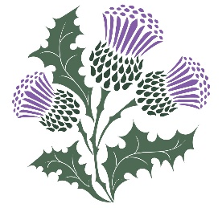
** Please only dance this if you know it well
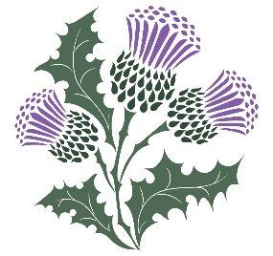
Admission $18
RSCDS Members $15
Juniors and non-dancers $5

