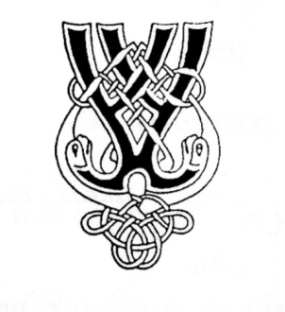
RSCDS NZ Branch Inc. Wellington Region
Region Classes 2024

5 Evening Classes - Basics Level
Tuesdays 7.30 – 9.30pm
May 7, 21, June 4, 18, July 2
Tutor: Diane Bradshaw
Cost: $45 for all five classes paid when registering; or $10 cash per class
(It is best if you attend all classes. This allows the teacher to develop your skills from those taught at earlier classes)
Please bring a water bottle
Basics Skills
For New Dancers or dancers wishing to consolidate their knowledge of basic steps and formations. You would typically be in the 1st or 2nd year of dancing.
Expect to: -
- Revisit the 5 basic steps – Skip Change, Pas de Basque/Setting, Slip Step, Strathspey Travelling, Strathspey Setting
- hone technique eg improving rhythm, hand and foot positioning, shape and timing/phrasing.
- integrate the above into some or all of the following formations – Poussette in quick time, Reel of Three, Allemande, Promenade, Grand Chain, Ladies Chain, Corners…perhaps more.
- dance these within suitable dances.
Please check with your club teacher if you are unsure if Basics is the right level for you
Registrations – to be received by April 30 (a week before your first class)
Please complete the online registration form by clicking here or go to the website www.wellingtonscd.org.nz

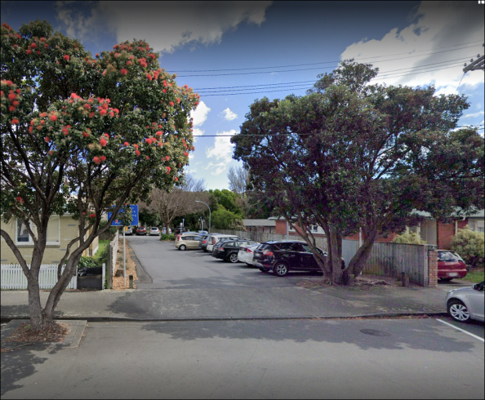
Venue: St David’s Multicultural Church Hall, down the drive off Elizabeth St. Look for the Region banner near the door.
