RSCDS NZ Branch Inc. Wellington Region
Region Classes 2024

2 Afternoon Classes - Advanced Level
Saturdays 1 - 4pm
Aug 17, 31
Tutor: Debbie Roxburgh
Cost: $35 for both classes paid when registering; or $20 cash per class
(It is best if you attend both classes. This allows the teacher to develop your skills from those taught at the earlier class)
Please bring a water bottle Afternoon Tea Live Music

Advanced Skills
For Dancers who are already consistently competent in footwork and rhythm, including transitions, dancing tidily with good control, handing and phrasing throughout. You can remember most common formations without prompting. You have a reasonable level of fitness.
Expect to: -
- work on all aspects of technique, footwork, rhythm and phrasing to achieve a higher standard.
- receive individual constructive critique.
- learn less common formations - eg Bourrel, Tournee, Tourbillon…perhaps more.
- dance these within more challenging dances.
The success of an advanced class depends on the whole team being of advanced standard. The Region will be checking with tutors to confirm eligibility for this class.
Registration – to be received by 10 Aug (a week before your first class)
Please complete the online registration form by clicking here or go to the website www.wellingtonscd.org.nz

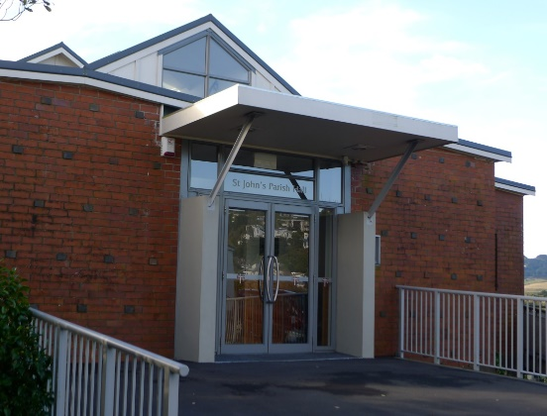
Venue: St John’s Anglican Church Hall, Bassett Rd, Johnsonville.
