RSCDS NZ Branch Inc. Wellington Region
Region Classes 2022

Series of Five Evening Classes at Basics 2 Level
7.30 – 9.30pm July 19th, Aug 2nd, 16th, 30^{th,} Sept 13th
Tutor: Susanna van der Gulik
Cost: $40 for all five classes.
(It is best if you attend all classes. This allows the teacher to build on from the material taught at earlier classes)
Please bring a water bottle.

Basics 2 - a continuation of Basics 1 classes
New Dancers or dancers wishing to consolidate their knowledge of basic skills. Basics 2 is intended to be an extension of the Basics 1 classes. Dancers who are familiar with the five basic steps, but did not attend Basics 1 may attend.
You would typically be in the 1st or 2nd year of dancing.

Expect to further
- hone technique eg improving rhythm, hand and foot positioning, shape and timing/phrasing.
- integrate the above into some or all of the following formations – Poussette in quick time, Reel of Three, Reel of Four, Allemande, Promenade, Grand Chain, Ladies Chain, Corners…perhaps more.
- dance these within suitable dances.
Please check with your club teacher if you are unsure Basics 2 is right for you
Applications – to be received no later than a week before your first class
Please complete the online registration form by clicking here or go to the website www.wellingtonscd.org.nz

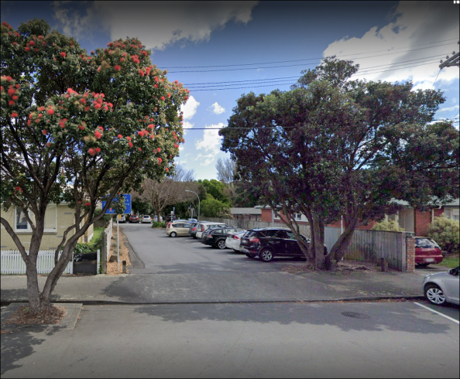
Venue: St David’s Multicultural Church Hall, down the drive off Elizabeth St.
