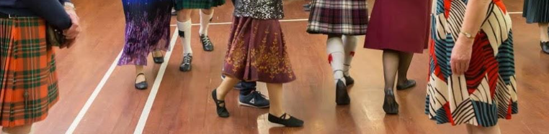

**Wellington Region Class**

**Basic Skills 2022**

**When:** Tuesday evening classes

3, 17 & 31 May and 14 & 28 June 2022

7.30 – 9.30pm

**Where:** St David’s Multicultural Hall

Elizabeth Street, Petone

**Tutor:** Catherine McCutcheon

**Cost:** $40 for all 5 classes

**Basic Skills 1**

**Aims and Objectives**

* To revisit the 5 basic steps Skip Change, Pas be Basque/Setting, Slip Step,

Strathspey Travelling, Strathspey Setting

* To hone technique eg improving rhythm, hand and foot positioning, shape and timing/phrasing
* To integrate the above into some or all of the following formations – Pousette in quick time, Reel of Three, Reel of Four, Allemande, Promenade, Grand Chain,

Ladies Chain, Corners

* To dance these within suitable dances

**Suitability**

* New Dancers or dancers wishing to consolidate their knowledge of basic skills.

You would typically be in the 1st or 2nd year of dancing

* You should be comfortable with Hands Across, Rights and Lefts, Hands Round, Figure of Eight as well as the 5 basic steps
* There has been so much disruption to dancing in the last 2 years, this class would be ideal to set the Refresh and Restart button!
* You can check with your club tutor if you are unsure whether this level is right for you.

Register at www.dancescottishwellington.org.nz or **click here**

**Finding the Venue – Drive down the drive off Elizabeth Street.**



